UNIT V: Autoencoder

role of the bottleneck layer: If the bottleneck layer were the same size or larger than the input layer (without regularization), the network would simply learn to copy the input directly without learning any meaningful patterns.

regularization: prevents models from overfitting the training data by adding a penalty for complexity

working of a deep autoencoder: A Deep Autoencoder consists of multiple hidden layers in both the encoder and the decoder. It is essentially a Deep Belief Network (DBN) trained to replicate inputs.

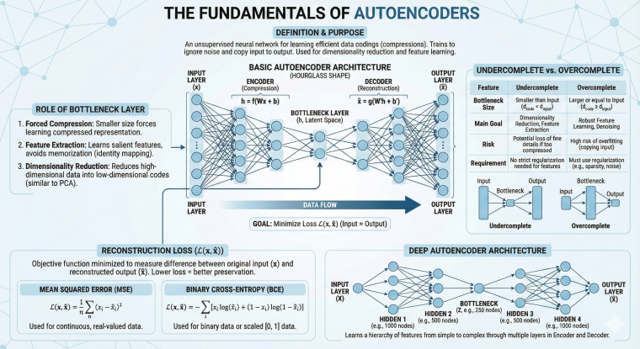

- Sparsity Constraint (L1): This technique forces the majority of neurons in the hidden layer to be inactive (zero).
- Weight Decay (L2 Regularization): Adds a penalty to the loss function proportional to the size of the weights ($w^2$).
- Dropout: Randomly turns off a percentage of neurons during training.
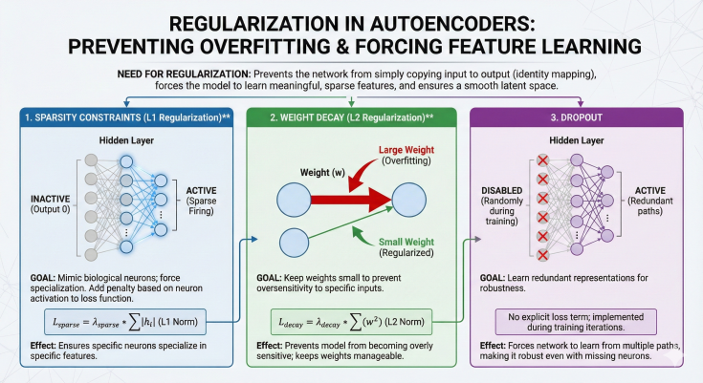

denoising autoencoders help in learning robust representations.
The model learns the "manifold" (the underlying shape) of the data distribution. This makes the features robust because they rely on the overall structure, not specific pixel intensities.

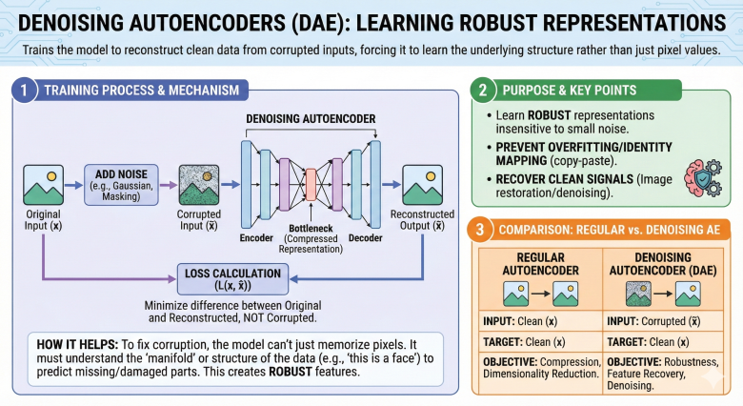

architecture and training process of a convolutional autoencoder.
- Encoder: Uses Convolution layers (Conv2D) to extract features and Pooling layers (MaxPooling) to downsample (reduce image size).
- Bottleneck: A set of feature maps representing the compressed image.
- Decoder: Uses Upsampling (or Conv2D Transpose) layers to increase the spatial dimensions back to the original image size.

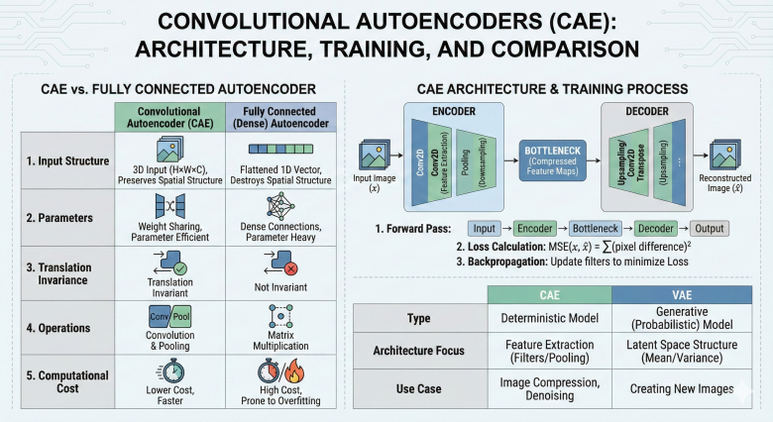

latent space representation in a variational autoencoder
the latent space is a fixed vector of numbers. However, in a Variational Autoencoder (VAE), the latent space is probabilistic.

concept of variational autoencoders (VAE) and explain how they differ from standard autoencoders.
A VAE is a generative model. While standard autoencoders map inputs to a specific point in the latent space, VAEs map inputs to a probability distribution (Gaussian). This makes the latent space continuous and smooth, allowing for the generation of new data by sampling from the space.
- Loss Function:
  - Standard AE: Only Reconstruction Loss.
  - VAE: Reconstruction Loss + KL Divergence Loss (which ensures the learned distribution stays close to a standard Normal distribution).
- Usage: Standard AE is for compression/denoising; VAE is for generation (creating deep fakes, new faces, etc.).

purpose of the reparameterization trick in VAEs
In a VAE, we need to sample a random vector z from the distribution defined by the encoder However, backpropagation (training) cannot flow through a random node. You cannot calculate gradients through a random sampling process.
The Solution (Reparameterization Trick):
We move the randomness to an independent variable (epsilon) so that the parameters $\mu$ and $\sigma$ remain deterministic and trainable.
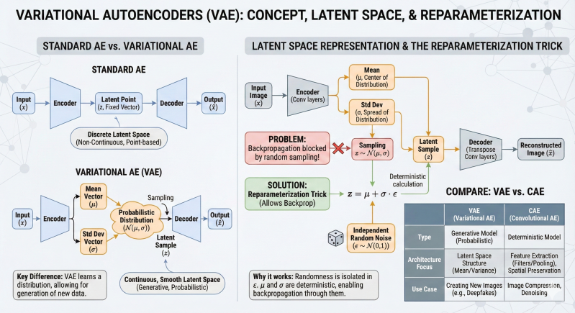

how autoencoders can be used for image compression.
"lossy" image compression (some detail is lost, but the file size is significantly smaller).
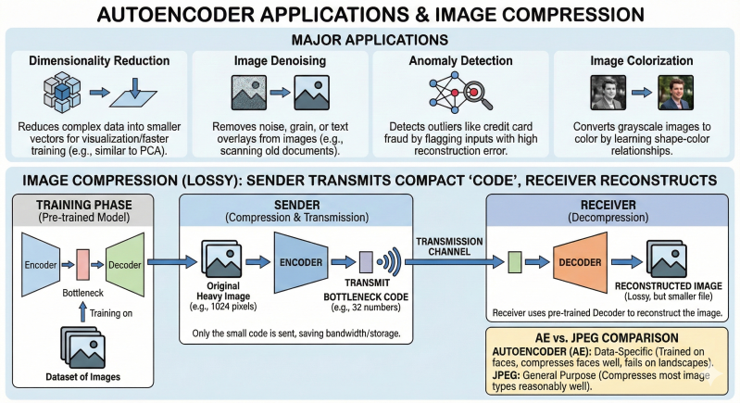

Based on the image you uploaded, here is a simple explanation of the Autoencoder-Based Network Traffic Anomaly Detection System. Think of this system as a security guard who has only ever seen "good" people. If someone comes in looking completely different (an "anomaly"), the guard stops them.

1. Phase 1: Dataset Preparation (Getting Ready)
- Raw Data: The system takes raw network traffic (packets, bytes, etc.).
- The Split: This is the most important part. The data is split into Normal Traffic and Attack Traffic.
- Crucial Rule: The system is trained ONLY on Normal Traffic. It is deliberately kept ignorant of what an attack looks like.

2. Phase 2: Training Phase (Learning Patterns)
This uses a special neural network called an Autoencoder. Its job is to copy the input to the output.
- Encoder: It takes the normal traffic data and compresses it into a small summary (called the Bottleneck or Compressed Representation).
- Decoder: It tries to rebuild the original data from that small summary.
- The Goal: The model practices until it can reconstruct "Normal" traffic perfectly with very little error (Low MSE).

3. Phase 3: Detection Phase (The Exam)
Now, we give the model real-world traffic (which could be normal or an attack) and see how it reacts.
- Reconstruction: The model tries to compress and rebuild this new traffic.
- Calculating Error: The system compares the Input (what came in) vs. the Reconstructed Output (what the model built).
  - Scenario A (Normal Traffic): The model recognizes the pattern (because it was trained on it). It rebuilds it easily. The error is LOW. Result: Normal.
  - Scenario B (Attack/Anomaly): The model has never seen this pattern before. It gets confused and does a bad job of rebuilding it. The error is HIGH. Result: Anomaly Detected.

Summary Logic for Exam Writing
If you need to write a concise answer, use this logic:
"This system uses an Autoencoder (a type of Deep Learning model). We train it only on normal data so it learns exactly what 'normal' looks like. When we test it, if the model can reconstruct the data with low error, it is normal. If the model fails to reconstruct the data (resulting in high error/loss), it means the data is strange and likely an anomaly or attack."
Would you like me to write out a specific 5-mark or 10-mark answer based on this explanation?
